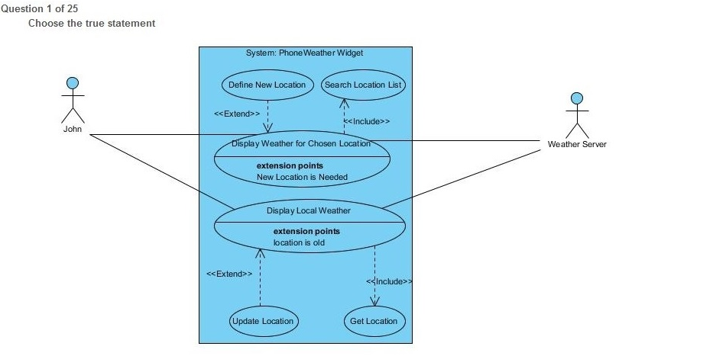

A. "Display Weather for Chosen Location" is an use case defining a concrete functionality that is offered to actor "John"

B. "Display Weather for Chosen Location" is an use case that defines a series of steps that are included every time a search is performec

C. "Display Weather for Chosen Location" is an extension point when new locations need to be defined

Question 2 of 25

The sequence diagram shows:

A. the roles of object collaboration

B. the interactions between objects, ordered in time, showing calls, messages exchanged

c. a graph with nodes-objects and edges-messages

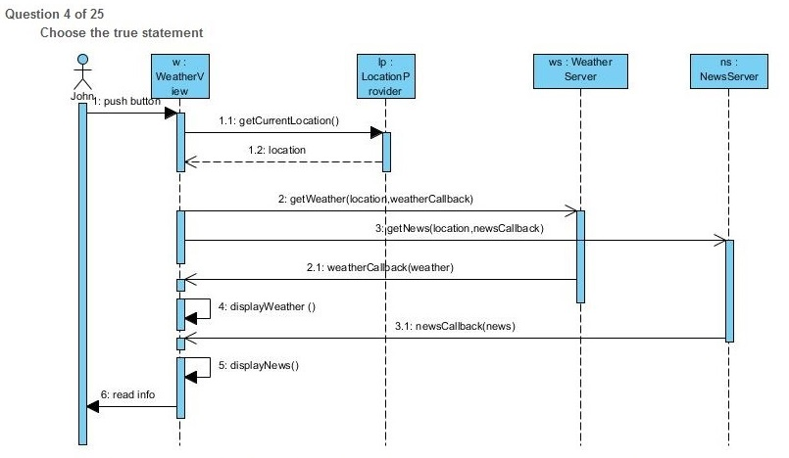

A. "w" is an object of class WeatherView; WeatherView class has to implement getCurrentLocation(), getWeather(), read info() methods

B. "w" is an object of class WeatherView; WeatherView class has to implement location, weather, news methods

C. "w" is an object of class WeatherView; WeatherView class has to implement newsCallback(), weatherCallback(), displayWeather() and displayNews() methods

Question 5 of 25

Inside the use case diagram, an actor is:

A. a behavior of a part of the system

B. an external user of the system, either human or another system

C. an internal entity of the system that interacts with exterior entities

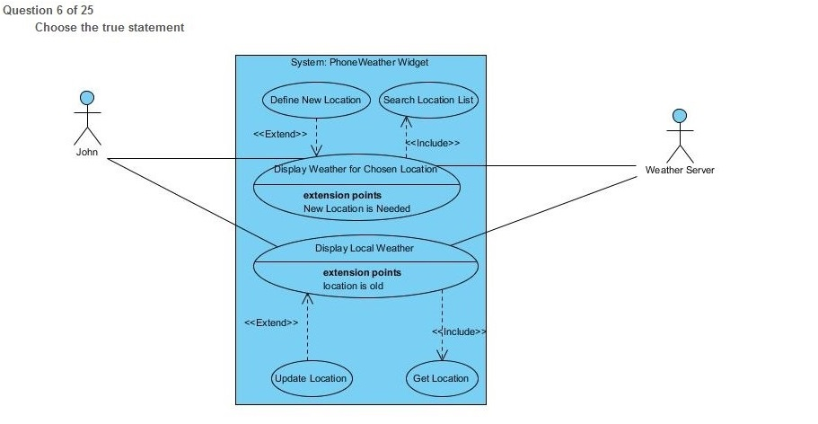

A. In the relationship between "Display Local Weather" (DLW) and "Get Location" (GL), DLW is the included use case that contains the main list of interaction, while DNL is the including use case that contains a list of interactions that occur only if the condition defined in the "Location is old" extension point is satisfied.

B. In the relationship between "Display Weather for Chosen Location" (DWCL) and "Define New Location" (DNL), DWCL is the including use case that contains the main list of interaction, while ONL is the included use case that contains a list of interactions that occur only if the condition defined in the "Location is old" extension point is satisfied.

C. In the relationship between "Display Local Weather" (DLW) and "Get Location" (GL), DLW is the including use case that contains the main list of interaction, while GL is the included use case that contains a list of interactions that occur every time OWL is run.

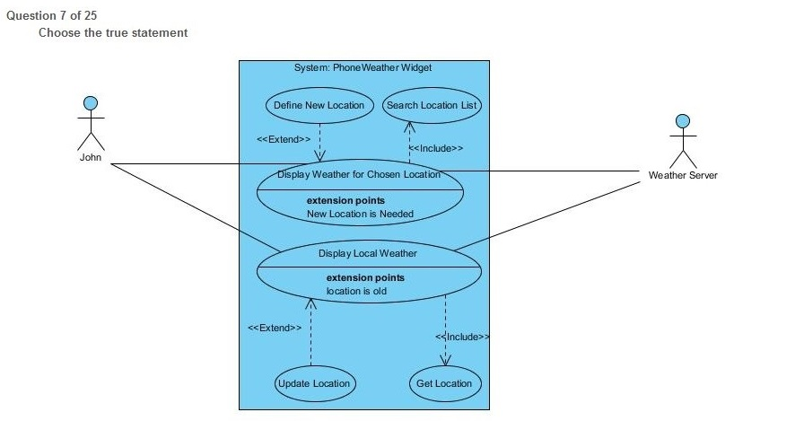

A. In the relationship between "Display Weather for Chosen Location" (DWCL) and "Define New Location" (DNL), DWCL is the extending use case that contains the main list of interaction, while ONL is the extended use case that contains a list of interactions that occur only if the condition defined in the "New Location Needed" extension point is satisfied.

B. In the relationship between "Display Weather for Chosen Location" (DWCL) and "Define New Location" (DNL), DWCL is the extended use case that contains the main list of interaction, while DNL is the extending use case that contains a list of interactions that occur only if the condition defined in the "New Location Needed" extension point is satisfied.

C. In the relationship between "Display Weather for Chosen Location" (DWCL) and "Define New Location" (DNL), DWCL is the extended use case that contains the main list of interaction, while DNL is the extending use case that contains a list of interactions that occur every time DWCL is run.

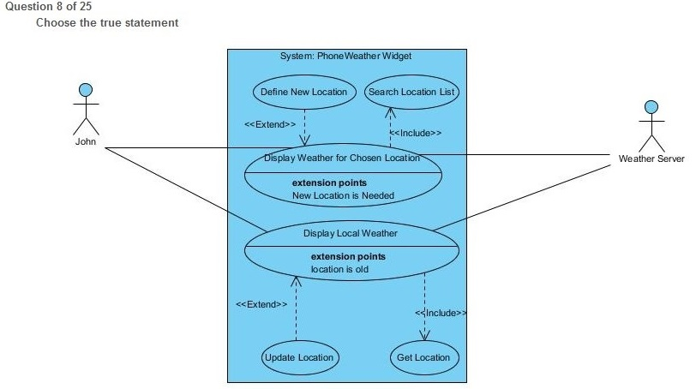

A. John is an employee that works inside the Weather company and administers a web server

B. John is the developer of Phone Weather Widget System

C. John is an actor that interacts with the application that displays the weather on the phone

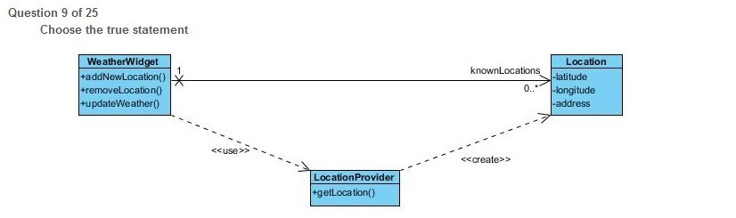

A. The association between WeatherWidget class and Location is one to zero or more navigable towards Location; this implies WeatherWidget holds a list/collection/array of objects of type Location with the name of knownLocations; inside the Location object we also have a reference towards the WeatherWidget

B. The association between WeatherWidget class and Location is one to zero or more navigable towards Location; this implies WeatherWidget holds a reference to an object of type Location with the name of knownLocations; inside the Location object we don't have a reference towards the WeatherWidget

C. The association between WeatherWidget class and Location is one to zero or more navigable towards Location; this implies WeatherWidget holds a list/collection/array of objects of type Location with the name of knownLocations; inside the Location object we don't have a reference towards the WeatherWidget

Question 10 of 25

The use case diagram is used for:

A. showing the deployment of a solution

B. specimng the required usages of a system

C. showing changes in a system

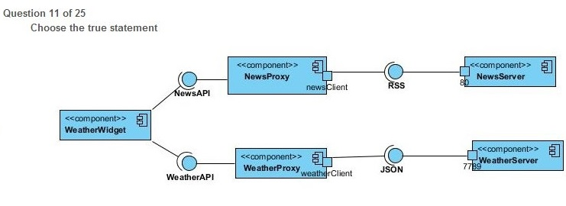

A. newsClient and weatherClient are TCP ports

B. WeatherWidget, NewsProxy and NewsServer are logical components of a system

C. WeatherWidget, NewsProxy and NewsServer are physical components of a system

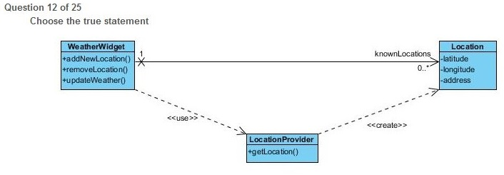

A. addNewLocation() is a public method; latitude is a private attribute

B. addNewLocation() is a public attribute; latitude is a public method

C. WeatherWidget class does not have any attributes; Location class does not have attributes

Question 13 of 25

In a use case diagram, the extends association between two use cases A and B (B extends A):

A. Optionally, under certain conditions, use case B must include the behavior use case A

B. Optionally, under certain conditions, use case A must include the behavior use case B

c. Shows that, necessarily, use case A must include the behavior of use case B

Question 14 of 25

An association with neither end marked by navigability arrows, A---B, means that:

A. the association is not navigable in neither direction

B. the association is navigable in both directions, each association end is owned by the classifier at the same end

C. the association is navigable in both directions, each association end is owned by the classifier at the opposite end

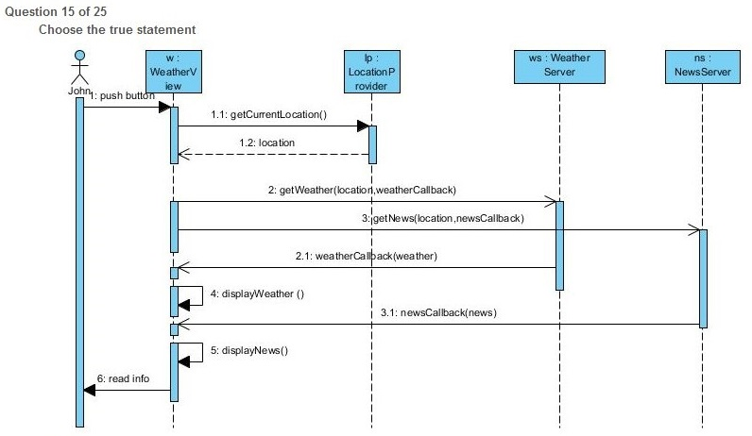

A. displayWeather() and displayNews() are self messages

B. displayWeather() and displayNews() are callback messages

C. displayWeather() and displayNews() are recursive messages

Question 16 of 25

In a use case diagram, the include association between two use cases A and B:

A. Shows that, necessarily, use case A must include the behavior of use case B

B. Shows the participation of an actor to a use case A and B

C. Optionally, under certain conditions, use case A must include the behavior use case B

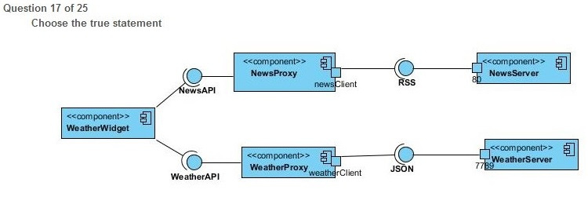

A. Component NewsProxy provides RSS protocol interface and requires NewsAPl interface

B. Component NewsProxy provides NewsAPl interface and requires an RSS protocol interface

C. Component NewsProxy provides newsClient interface

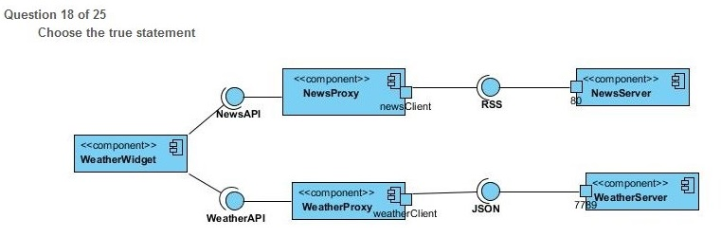

A. weatherClient port represents an entry point for JSON messages exchaged between WheatherProxy component WeatherServer

B. weatherClient port connects to remote port 80

C. weatherClient port listens to remote port 7789

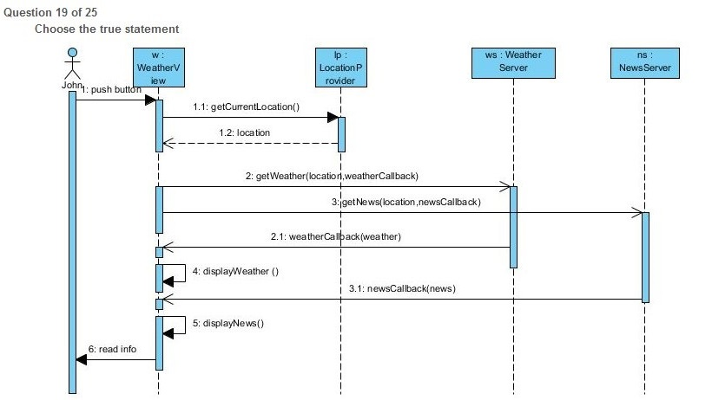

A. getCurrentLocation() method needs to be implemented in WeatherView class; getCurrentLocation() call returns "location" result to its caller "Ip" object

B. getCurrentLocation() method needs to be implemented in LocationProvider class; etCurrentLocation() call is synchronous and processing in "w" is blocked until the "location" result is returned

C. getCurrentLocation() method needs to be implemented in LocationProvider class; etCurrentLocation() call is asynchronous and processing in "w" is not blocked until the "location" result is returned

Question 20 of 25

An association between two classes A and B, with one end marked by a navigability arrow, A--\*B, means that:

A. the association is navigable from A to B,the marked association end is owned by the class A, the opposite association end is owned by the association.

B. the association is navigable from A to B,the marked association end is owned by the class B, the opposite association end is owned by the association.

C. the association is navigable from A to B,the marked association end is owned by the class A, the opposite association end is owned by class B.

Question 21 of 25

Diagrams showing only interactions are:

A. state diagram, activity diagram

B. composite structure diagram, deployment diagram

C. sequence diagram, collaboration diagram

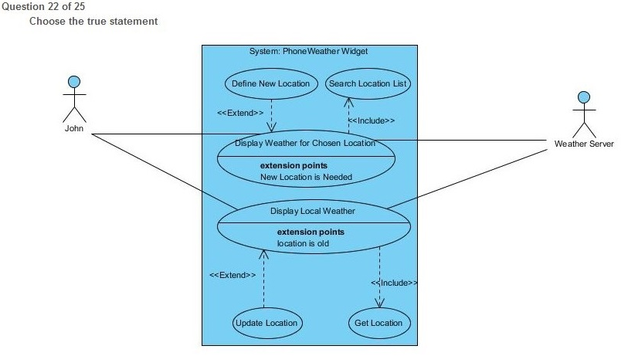

A. The arrow between "Update Location" and "Display Local Weather" is wrongly pointed, should be from "Display Local Weather" to "Update Location"

B. "Display Local Weather" use case extends "Update Location" use case with an alternative set of steps run if extension condition is satisfied

C. "Update Location" use case defines interactions that are executed only if the condition for extension point "Location is old" is satisfied as an alternative set of steps for "Display Local Weather"

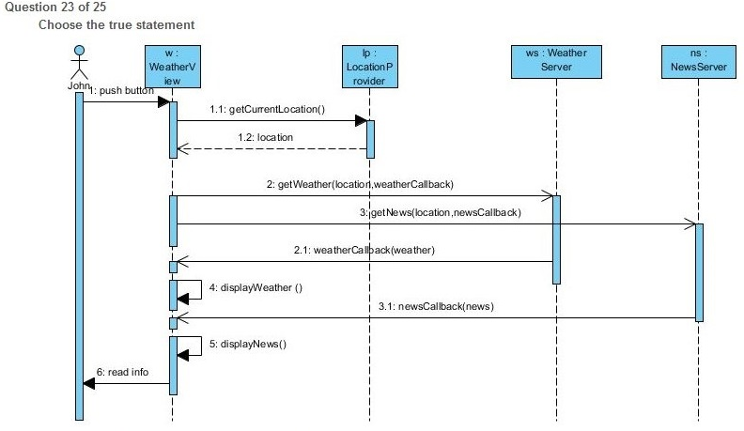

A. location, weatherCallback(), newsCallback() are return messages

B. displayWeather(), displayNews() have return messages; getNews() call is made before getWeather()

C. "w","lp", "ws", "ns" are objects of their respective classes specified after

Question 24 of 25

An use case is:

A. the description of a set of actions that produce a relevant result, speciMng the behavior of a part of the system

B. an user of the system that knows how to operate the system

C. a diagram showing what the system is supposed to do

Question 25 of 25

Diagrams for modeling only static aspects of a system are:

A. use case diagram, activity diagram, components diagram

B. sequence diagram, state diagram, activity diagram

C. component diagram, package diagram, class diagram